**Experiment-1**

**Aim of Experiment: Write a Program to install and run the Matplotlib?**

**Installation :**

!python -mpip install -U matplotlib

**Importing matplotlib :**

**from matplotlib import pyplot as plt**

**or**

**import matplotlib.pyplot as plt**

**Simple Plot**

import matplotlib.pyplot as plt

# initializing the data

***x = [10, 20, 30, 40]***

***y = [20, 30, 40, 50]***

# plotting the data

***plt.plot(x, y)***

# Adding the title

***plt.title("Simple Plot")***

# Adding the labels

***plt.ylabel("y-axis")***

***plt.xlabel("x-axis")***

***plt.show()***

**Output:**

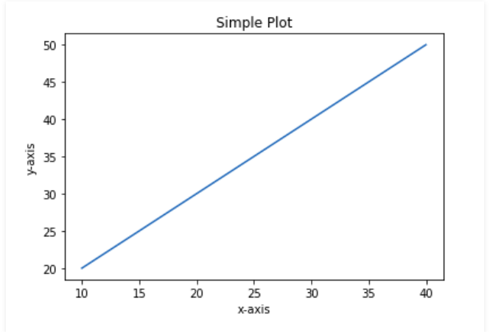

**Conclusion:** By doing above experiment successfully we implemented it.

**Experiment-2**

**Aim of Experiment:- Write a program to create Pyplot using Matplotlib?**

**Syntax:**

*matplotlib.pyplot.plot(*args, scalex=True, scaley=True, data=None, **kwargs)*

**Code:**

# Python program to show pyplot module

***import matplotlib.pyplot as plt***

***plt.plot([1, 2, 3, 4], [1, 4, 9, 16])***

***plt.axis([0, 6, 0, 20])***

***plt.show()***

**Output:**

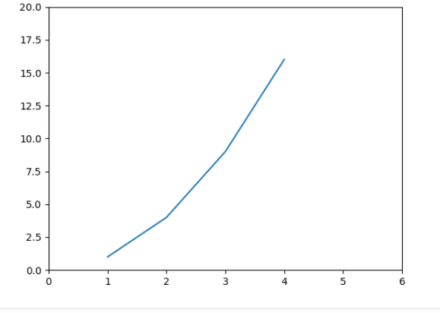

**Conclusion:** By doing above experiment successfully we implemented it.

**Experiment-3**

**Aim of Experiment: Write a program to create a Figure Class using matplotlib?**

**Syntax:**

*class matplotlib.figure.Figure(figsize=None, dpi=None, facecolor=None, edgecolor=None, linewidth=0.0, frameon=None, subplotpars=None, tight_layout=None, constrained_layout=None)*

**Code:**

# Python program to show pyplot module

***import matplotlib.pyplot as plt***

***from matplotlib.figure import Figure***

# Creating a new figure with width = 5 inches

# and height = 4 inches

***fig = plt.figure(figsize =(5, 4))***

# Creating a new axes for the figure

***ax = fig.add_axes([1, 1, 1, 1])***

# Adding the data to be plotted

***ax.plot([2, 3, 4, 5, 5, 6, 6], [5, 7, 1, 3, 4, 6 ,8])***

***plt.show()***

**Output:**

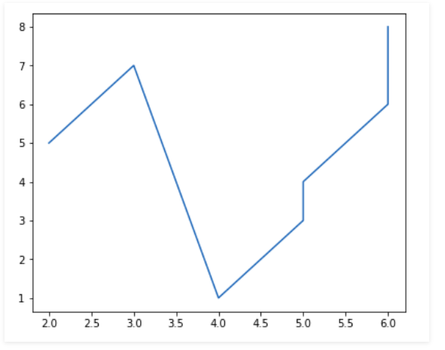

**Conclusion:** By doing above experiment successfully we implemented it.

**Experiment-4**

**Aim of Experiment: Write a program to create multiple plot using matplotlib?**

**Code:**

# Python program to show pyplot module

***import matplotlib.pyplot as plt***

***from matplotlib.figure import Figure***

# Creating a new figure with width = 5 inches

# and height = 4 inches

***fig = plt.figure(figsize =(5, 4))***

# Creating first axes for the figure

***ax1 = fig.add_axes([0.1, 0.1, 0.8, 0.8])***

# Creating second axes for the figure

***ax2 = fig.add_axes([0.5, 0.5, 0.3, 0.3])***

# Adding the data to be plotted

***ax1.plot([5, 4, 3, 2, 1], [2, 3, 4, 5, 6])***

***ax2.plot([1, 2, 3, 4, 5], [2, 3, 4, 5, 6])***

***plt.show()***

**Output:**

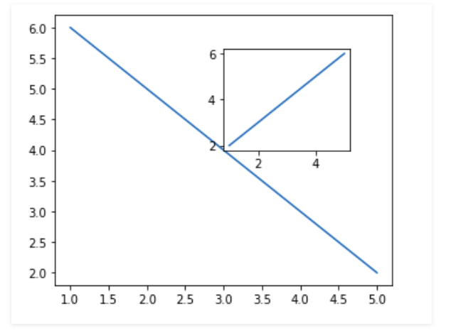

**Conclusion:** By doing above experiment successfully we implemented it.

**Experiment-5**

**Aim of Experiment:- Write a program to create different types of plot using matplotlib?**

Line Graph

**Code:**

***import matplotlib.pyplot as plt***

# data to display on plots

***x = [3, 1, 3]***

***y = [3, 2, 1]***

# This will plot a simple line chart

# with elements of x as x axis and y

# as y axis

***plt.plot(x, y)***

***plt.title("Line Chart")***

# Adding the legends

***plt.legend(["Line"]***

***plt.show()***

**Output:**

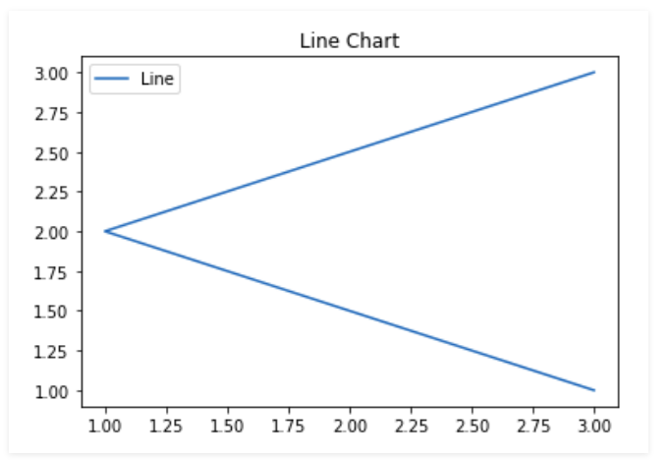

**Conclusion:** By doing above experiment successfully we implemented it.

### *Bar chart*

### Code:

***import matplotlib.pyplot as plt***

# data to display on plots

***x = [3, 1, 3, 12, 2, 4, 4]***

***y = [3, 2, 1, 4, 5, 6, 7]***

# This will plot a simple bar chart

***plt.bar(x, y)***

# Title to the plot

***plt.title("Bar Chart")***

# Adding the legends

***plt.legend(["bar"])***

***plt.show()***

**Output:**

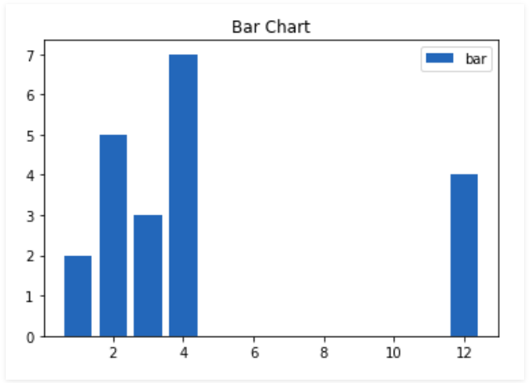

**Conclusion:** By doing above experiment successfully we implemented it.

### Histograms

### Code:

***import matplotlib.pyplot as plt***

# data to display on plots

***x = [1, 2, 3, 4, 5, 6, 7, 4]***

# This will plot a simple histogram

***plt.hist(x, bins = [1, 2, 3, 4, 5, 6, 7])***

# Title to the plot

***plt.title("Histogram")***

# Adding the legends

***plt.legend(["bar"])***

***plt.show()***

***Output:***

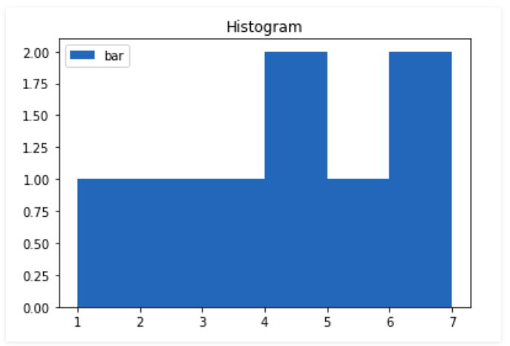

**Conclusion:** By doing above experiment successfully we implemented it.

### Pie Chart

### Code:

### *import matplotlib.pyplot as plt*

### # data to display on plots

### *x = [1, 2, 3, 4]*

### # this will explode the 1st wedge

### # i.e. will separate the 1st wedge

### # from the chart

### *e =(0.1, 0, 0, 0)*

### # This will plot a simple pie chart

### *plt.pie(x, explode = e)*

### # Title to the plot

### *plt.title("Pie chart")*

### *plt.show()*

***Output:***

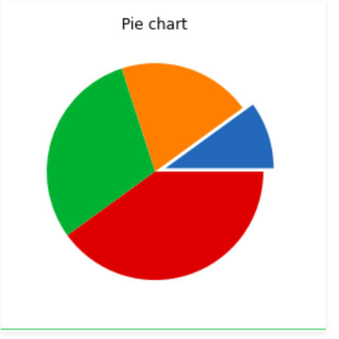

**Conclusion:** By doing above experiment successfully we implemented it.